Completing an Application FAQ

Below are a few of our frequently asked Applicant questions within SurveyMonkey Apply.
For questions on updating your account details and login credentials, you can refer to our General Account FAQ.
Application FAQs
- How do I create a new application?
- How do I delete my application?
- How do I submit my application?
- How do I preview my application?
- Can I print/download my online application?
- How do I edit a completed task?
- Why can't I edit my task?
- I get an error when uploading a file
- "Whoops! We couldn't find what you were looking for."
- The deadline has passed, what can I do?
- Why is my application locked?
- My payment wasn't accepted/I was double-charged, what do I do?
- I submitted my application but didn't receive a confirmation email
- How do I Sign a Form?
Recommendation FAQs
- My recommender hasn't received their email, what should I do?
- My recommendation task says "In Progress"
- I want to change the information of my recommender.
Email FAQs
- How do I change my notification preferences?
- Why am I not receiving any emails from the site?

How do I create a new application?

I haven't created an application yet
If you have no Applications created yet, within the site you can:
- Click View Programs
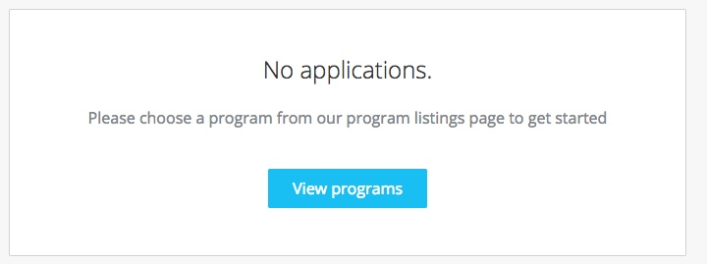
- You may need to complete an Eligibility Quiz if required by the site.
- Once you've completed the eligibility quiz, or if there is no quiz enabled, you will be able to View the programs.
- Click MORE > for the program you wish to apply for
- Click Apply
Based on site configurations put in place by the administrators, you may not be able to create an application for a program. If you experience difficulties creating an application, you can reach out to the administrators of the site.

I have existing applications on the site
In the case where you've already created an application on the site and wish to create a new one:
- Click Programs in the top in the top right corner
- Click MORE > for the program you wish to apply for
- Click Apply
Based on site configurations by the administrators, you may not be able to create more than one application. If you're experiencing difficulties creating more than one application, you can reach out to the administrators of the site.

How do I delete my application?
If you have started the application but no longer wish to continue, you can choose to Delete your application.
You won't be able to delete a Submitted application. You will need to contact the administrators of the site for further help in regards to this.
There are two ways to Delete the application:

From the "My Applications" page
- Click on the More Options icon in the top right corner of the tile of the application you wish to Delete
- Select Delete
- You will receive the confirmation message "Are you sure you want to delete your application? You won't be able to undo this action"
- Click Yes to confirm

From Within the Application
If you're on the application page with the list of Tasks to complete, to Delete your application:
- Click on the More Options icon in the top right corner of the application.
- Select Delete
- You will receive the confirmation message "Are you sure you want to delete your application? You won't be able to undo this action"
- Click Yes to confirm

How do I submit my application?
To be able to submit your application you will first need to complete all required tasks within your application. Additionally, you will need to ensure that you've verified your email.
A Banner will appear within your portal until you've verified your account. Click to Send Verification Link and follow the instructions sent in the email.
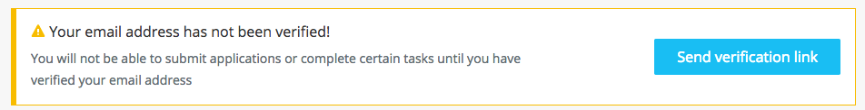
Once all tasks are complete, submit your application by performing the following steps:
- Within the application to submit, select Review & Submit
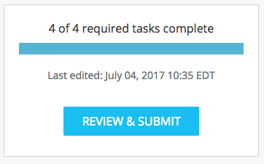
- Review application materials
- Once you've reviewed all your completed tasks, you can click to Submit Your Application.
- Choose to proceed back to your applications or View More Programs.

How do I preview my application?
There are two ways to Preview your application within the site:

From the My Applications Page
- Click on the More Options icon in the top right corner of the tile of the application you wish to Preview
- Select Preview

From Within the Application
If you're on the application page with the list of Tasks to complete, to preview your application:
- Click on the More Options icon in the top right corner of the application.
- Select Preview

Can I print/download my online application?
There are three ways to print/download your application within the site:

From the "My Applications" Page
- Click on the More Options icon in the top right corner of the tile of the application you wish to download
- Click Download

From Within the Application
If you're on the application page with the list of Tasks to complete, to download your application:
- Click on the More Options icon in the top right corner of the application.
- Click Download

From the Preview
- Within the Preview, click Download in the top right corner

How do I edit a completed task?
If you have previously pressed Marked as Complete on a form, but have not yet Submitted your application, you can choose to make Edits to your task.
- Enter your application
- Click on the task you wish to edit
- Click on the More Options icon in the top right corner of the task
- Click Edit
- Click Previous/ Next to navigate between the pages and make your changes
- When done, navigate to the last page and press Mark as Complete
If you experience difficulties editing your task or this option isn't available, see Why can't I edit my task?
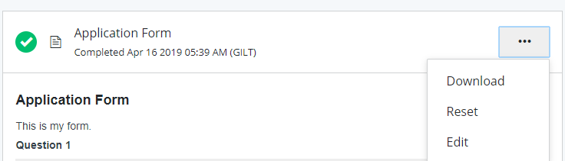

Why can't I edit my task?
If your tasks Cannot be Modified or say The task cannot be started at this time, there are a few main reasons why this could occur.
- The deadline has passed or the administrators don't want you to start until a specific date.
- Prerequisites haven't been met. Meaning you will need to complete other tasks before you're able to start this one.
- You've completed your task and the administrators don't wish for you to be able to make changes.
- Your application is locked.
Contact the administrator of the site if you aren't able to edit a task and wish to understand why.

I get an error when uploading a file
There are a few potential reasons why you may experience issues uploading your file:
- The file isn't in an available format.
Check to ensure that the file type you're trying to upload matches the requested formats.
- The file doesn't meet size restrictions.
Check to ensure that the file type you're trying to upload does not exceed the maximum file size of the upload task.
- You're attempting to Upload more files than allowed
Confirm that the number of files you're uploading is within the range of the minimum and the maximum number of files required.
- The file is encrypted
SurveyMonkey Apply won't accept encrypted files. To upload your file, it will need to be unencrypted.
- The file is corrupted
It is possible that the file you're trying to upload is a corrupted file. To resolve the issue, re-save the file to a new folder on your computer and attempt to upload the file again.
- A task related issue.
Depending on the issue it's also possible that the error is related to another Setting on the task. For example, you're unable to edit the task.

"WHOOPS! We Couldn't find what you were looking for."
If you're receiving this error warning, then the page you're attempting to access isn't available to you. This is based on restrictions on the site and is most likely related to not having permission to currently edit the task. For more information in regards to this you can refer to the section on Why can't I edit my task?

The deadline has passed, what can I do?
The administrators may set deadlines when they wish to restrict access to the application after that date.
As this is a configuration set by the administrators of the site you will need to contact them, for information on any process past a deadline.

Why is my application locked?
If your application appears locked within the site. It has either been locked manually by an administrator, or by an automation on the site.
Contact the administrator of the site if you wish to understand why your application is locked.

My Payment wasn't accepted/I was double charged, what do I do
If you experience an issue with completing a payment, we would recommend reaching out to the administrators of the site. If you've completed the payment, but, the task isn't being updated within the site, it means that the payment processor isn't notifying the SurveyMonkey Apply system to let us know that the payment has been processed.
The administrators will need to be contacted to confirm if they have received your payment and to potentially update any configurations within the payment processor, if necessary.

I submitted my application but didn't receive a confirmation email
A confirmation email is part of the configuration of the site set by the administrators. If you submit your application and haven't received an email, check your spam/junk folder. If you still aren't able to find the email, contact the administrators to confirm if one was sent.
You can also refer to I am not receiving any emails from the site for more information.

How do I Sign a Form?
If you're completing a form and it asks you to Sign the form:
- Click and Drag your mouse across the screen to draw your signature on to the form.
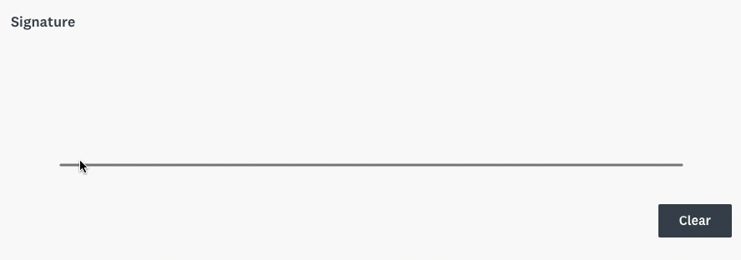

My recommender hasn't received their email, what should I do?

If your recommender hasn't received an invitation to recommend your application, you can take the following steps:
1. Check to ensure that the email you entered is correct and there are no spelling mistakes. If the email is incorrect you can change this information and resend the invite.
If the information is correct
2. Have the recommender check their Spam/Junk Folder.
If they aren't able to locate the email in any inbox
3. Resend the Invitation. Click to edit the Get a Recommendation task and Resend the Invitation to them. Repeat step 2 if necessary.
If both options don't work
4. Have the recommender contact our support team for Login Assistance. It is important that they contact us themselves with no CC's on the email. Once we receive their email we will be able to assist them with logging into the site.

My recommendation task says "In Progress"
If your recommender task currently says In Progress
- Click to enter the task within your application
- This will tell you the status of the recommendations. For example, you can see if it's Requested/Not Started, In Progress, or Received.
- If it's marked as Received click on Mark as Complete, to complete the task.
If the task states Requested or Not Started, it means that the recommender hasn't started their recommendation. We would recommend reaching out to them to ensure that they have received the invite to log in to the site. If they haven't received the invite please refer to My recommender hasn't received their email, what should I do?.

I want to change the information of my recommender
To change the information of your recommender, you will need to Delete your request. This will allow you to Start a new request.
WARNING! Deleting the request will rescind the invitation and delete any progress the recommender may have made on their task. Once you send them another request they will be able to start a new recommendation form.

How do I change my Notification Preferences?
If you wish to change your notification preferences in the site:
- Log into your account
- Click on your Name in the top right corner of the page
- Select My Account
- Click Notifications
- Enable/Disable the emails you no longer wish to receive.
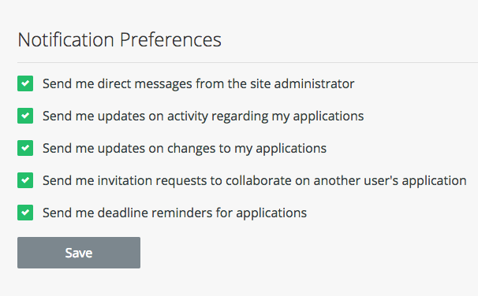

Why am I not receiving any emails from the site?
If you're currently not receiving any emails from the site:
- Ensure that noreply@mail.smapply.io is added to your safe sender list within your email account.
- Ensure that your email is verified within the site. If you're receiving this notification at the top of your page, then it's possible that you won't receive other emails from the site.
- Ensure that you're subscribed to receive emails from the site.
- Check your Spam Folder to verify whether the email was sent to your Spam/Junk folder.
- Depending on the email(s) you're expecting to receive, reach out to the administrators to ensure that an email was sent out.

